
Geography Group Assignment. Section-CELS-4 Group-1
Eyoel Mulugeta -------------------------------------------------------------UGR/4897/18
Yeabsira Melese -------------------------------------------------------------UGR/3043/18
Edna Yohannes -------------------------------------------------------------UGR/5270/18
Edlawit Amsalu ------------------------------------------------------------- UGR/5513/18
Yididya Fikru -------------------------------------------------------------UGR/1844/18
Yohannes Bogale -------------------------------------------------------------UGR/7893/18
Yishak Waktola -------------------------------------------------------------UGR/3640/18
Yedideya Tamrat ------------------------------------------------------------- UGR/4362/18
Betselot Aklilu ------------------------------------------------------------- UGR/2537/18
Tizita Moges -------------------------------------------------------------UGR/3424/18
Dagmawit Fitsum ------------------------------------------------------------- UGR/4942/18
Soliana Gebeyehu ------------------------------------------------------------- UGR/1946/18
Soliyana Tadesse ------------------------------------------------------------- UGR/2369/18
Nahom Tewodros ------------------------------------------------------------- UGR/2857/18
Pia Pierre -------------------------------------------------------------UGR/9597/18
Yitbarek Teklu ------------------------------------------------------------- UGR/3869/18
Yididiya Dereje ------------------------------------------------------------- UGR/6609/18
Ytbarek Solomon ------------------------------------------------------------- UGR/0686/18
Yosef Nigusu ------------------------------------------------------------- UGR/1767/18
Dagmawi Haile ------------------------------------------------------------- UGR/0020/18
Soud Jemal ------------------------------------------------------------- UGR/6337/18
Nahom Yaregal ------------------------------------------------------------- UGR/8981/18
Elroe Dereje ------------------------------------------------------------- UGR/7185/18
Hanan Isa------------------------------------------------------------------------ UGR/2435/18

1.Discuss the current population dynamics (fertility, mortality & migration) situation in Ethiopia.
Ethiopia is situated in the Horn of Africa and is the second most populous country in the African continent.The country is navigating a pivotal phase in its demographic history which is characterized by an ongoing shift within the Demographic Transition Model(DTM).Structurally advancing from a high-fluctuation stage(Stage 1) well into the late expansion phase(Stage 2 moving toward Stage 3),Ethiopia exhibits a distinct lag between rapidly declining mortality rates and more gradually falling fertility levels.
We will evaluate and show ethiopia’s contemporary population dynamics,dissecting the tripartite engines of demographic alteration fertility, mortality and migration.We will address internal variations specifically regional fertility differences and also analyze how socio-economic policies,climate change,environmental pressures and geopolitical factors shape the country’s demographic profile.Finally,we will highlight the methodological limitations and structural uncertainties coming from the prolonged absence of a national census concluding with an analysis of the socio-economic implications of these dynamics on the potential fulfillment of a demographic dividend.

1. Introduction,Data Limitations and Macro-Demographic Profile

1.1 Census Absence and Statistical Uncertainty
Any kind of rigorous analysis of Ethiopia’s contemporary demographic profile must first acknowledge a fundamental methodological limitation which is the high level of uncertainty underlying all current population estimates.Ethiopia’s last comprehensive National Population and Housing Census was conducted in 2007.The fourth national census originally scheduled for 2017,has been repeatedly postponed due to logistical constraints,regional security challenges, political transitions and public health disruptions.
Consequently, contemporary figures including the widely cited national population estimate of over 135 million are derived from statistical projections, mathematical modeling and localized sample surveys such as the Ethiopia Demographic and Health Surveys (EDHS) and UN projections.Because baseline indicators are nearly two decades old,sub-national growth rates, precise migration tallies and regional urban-rural ratios are subject to varying margins of error. This data deficit introduces a layer of statistical uncertainty that complicates long term developmental planning,macroeconomic modeling and the precise allocation of state resources.

1.2 Demographic Momentum and Age Structure
Despite these measurement uncertainties,the overarching structural trajectory of Ethiopia's population remains clear heavily driven by demographic momentum.Demographic momentum refers to the tendency of a population to continue growing even after fertility rates have declined to or toward replacement level.This occurs because previous historical cycles of high fertility create an exceptionally large cohort of children who subsequently transition into their reproductive years.
Because of this built-in momentum,even if Ethiopia’s fertility rate dropped instantly to the replacement level of 2.1 children per woman,the absolute population would continue to expand by millions for several decades.The population architecture remains highly expansive and youthful:
- Age 0–14: Approximately 39% of the population.
- Aged 15–64: Approximately 58% of the population.
- Aged 65 and above: Approximately 3% of the population.

2. Fertility Dynamics:Macro Trends and Regional Heterogeneity

2.1 Crude Birth Rate(CBR) and Total Fertility Rate(TFR)
The Crude Birth Rate(CBR) is defined as the annual number of live births per 1,000 members of the population and it currently stands at approximately 30 to 32 births per 1,000 people. While this represents a significant contraction from historical peaks in the 1980s and 1990s (when the CBR regularly exceeded 45 per 1,000),it remains high relative to global averages.
This CBR is anchored by a steadily declining but high national Total Fertility Rate(TFR), currently estimated at roughly 3.6 to 3.9 children per woman.The macro-level descent of fertility is historically documented as follows:
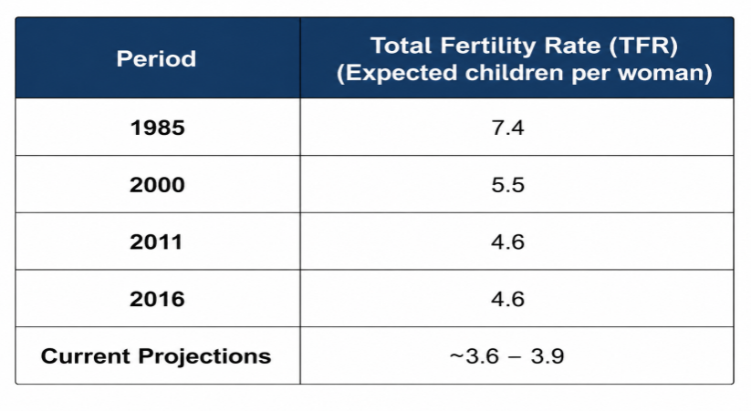
The primary driver of the national decline has been the structural deployment of the rural Health Extension Program(HEP).This decentralized initiative has utilized tens of thousands of local female health extension workers to distribute family planning resources, raise reproductive health awareness and increase the Modern Contrateptive Prevalence Rate (mCPR) across rural communities.

2.2 Deep Regional Fertility Variations
The national TFR average is a composite that obscures profound geographic and cultural polarization. Fertility behaviors in Ethiopia do not merely present an urban-rural split they display sharp regional variations determined by local socioeconomic development,religious and cultural traditions and structural urbanization.
- Ultra-Low Urban Fertility(Addis Ababa and Dire Dawa):In major metropolitan centers fertility has collapsed to sub-replacement or near-replacement levels.Addis Ababa exhibits a TFR estimated between 1.4 and 1.8 children per woman a rate comparable to many industrialized Western nations.This urban shift is driven by delayed ages at first marriage,high levels of female secondary and tertiary educational attainment,widespread formal workforce participation and the high cost of urban child-rearing.
- High Agrarian and Pastoralist Fertility(Somali, Afar, and Oromia):In stark contrast,the peripheral and predominantly pastoralist or agro-pastoralist regions maintain some of the highest fertility rates on the African continent.The Somali and Afar regional states exhibit TFRs estimated between 5.5 and 6.5 children per woman.In these regions, traditional pastoral economies rely on large family sizes for herd management,access to formal healthcare and contraceptive technologies remains structurally limited and deepseated cultural norms heavily value large lineages.Major agrarian regions such as Oromia and the Southern Nations Nationalities and Peoples' Region(SNNPR) blocks occupy a middle tier with TFRs generally hovering between 4.0 and 4.8 where children continue to serve as vital agricultural labor units and informal old age security.

3. Mortality Dynamics:Epidemiological Shifts and Key Statistics

3.1 Crude Death Rate(CDR) and Life Expectancy
The transition of Ethiopia into the later stages of the DTM is fundamentally verified by its success in suppressing mortality.The country's Crude Death Rate(CDR) the annual number of deaths per 1,000 individuals has dropped to approximately 5.8 to 6.0 deaths per 1,000 people.This represents a dramatic decline from the late 20th century when the CDR routinely surpassed 15 deaths per 1,000 due to war,famine and unmitigated infectious disease outbreaks.
Concurrently life expectancy at birth has experienced an upward trajectory rising from roughly 51 years in 2000 to an estimated 65 to 67 years.This structural leap reflects the systematic mitigation of large scale famine related mortality spikes through improved early warning systems, agricultural safety nets and a primary healthcare architecture focused on preventative care.

3.2 Infant,Child and Maternal Mortality Profiles
The systematic expansion of maternal and child health interventions has yielded tangible progress in early age and reproductive mortality indicators though severe challenges remain:
- Infant Mortality Rate(IMR):The IMR the number of infants dying before their first birthday per1,000 live births has dropped significantly over the past two decades.According to UN Inter-agency Group for Child Mortality Estimation(UN IGME) and modeled data the IMR is estimated at approximately 36 deaths per 1,000 live births representing a major decline from the year 2000 when it exceeded 70deaths per1,000.
- Under-Five Mortality Rate:The probability of a child dying before reaching age five has experienced a parallel reduction, falling to approximately 47death per 1,000 live births.This achievement reflects targeted immunizations better diarrhea management through oral rehydration therapy and localized malaria interventions.
- Maternal Mortality Ratio(MMR):While the MMR has seen substantial long-term reduction, the maternal mortality burden remains high.Modeled international estimates indicate the MMR stands at approximately 195 to 207 maternal deaths per 100,000 live births.The persistence of this figure is heavily tied to deep geographic inequities; while urban centers feature high institutional delivery rates many births in remote rural and pastoralist zones still take place without skilled birth attendants or access to emergency obstetric care.

4. Migration Dynamics:Displacement, Climate Shifts and Talent Flows
Migration in Ethiopia has grown increasingly complex evolving from historical rural to urban shifts into a multi layered matrix driven by economic aspirations,environmental shocks,political friction and international labor demands.

4.1 Internal Displacement and Climate-Induced Migration
Internal population movements are categorizable into two separate structural streams:voluntary economic urbanization and involuntary internal displacement.

Climate Migration and Environmental Push Factors
Ethiopia’s population is uniquely vulnerable to climate change given that over 70% of the population relies on climate-sensitive subsistence agriculture and pastoralism.While climate factors rarely act in total isolation,accelerated environmental degradation,severe soil erosion in the highlands and unprecedented sequential droughts in the southern and eastern lowlands (such as the Somali, Oromia and Afar regions)have triggered a noticeable surge in climate migration. As ancestral pastoral lands and erratic rainfall patterns render traditional livelihoods increasingly precarious,affected populations frequently migrate into peri-urban settlements or secondary cities.Rather than a total abandonment of rural areas,this operates as an accelerant to existing economic urbanization patterns,placing additional strain on municipal infrastructures.

Refugee Influxes and Internal Displacement (IDPs)
Compounding climate-driven migration,localized inter-communal friction and regional boundary conflicts have created a substantial population of internally displaced persons(IDPs).According to data from the International Organization for Migration(IOM) Displacement Tracking Matrix(DTM),Ethiopia hosts a massive internal displacement population with estimates hovering between 3.0 million and 4.0 million IDPs due to conflict and natural disasters.
Global Crisis Response Platform-IOM
Concurrently,Ethiopia serves as a major regional oasis for those fleeing international instability.Data from the United Nations High Commissioner for Refugees(UNHCR)indicates that Ethiopia hosts over1.12 million registered refugees and asylum seekers,primarily originating from South Sudan(approx. 43%),Somalia(approx. 32%),Eritrea(approx. 15%) and Sudan(approx. 9%).This massive dual burden of IDPs and international refugees profoundly alters the local demographic balance of host regions like Gambella and Somali straining basic resource distribution networks.
Operational Data Portal - UNHCR

4.2 International Migration:Brain Drain and Labor Corridors
Ethiopia's international migration profile is characterized by a dual dynamic:the irregular migration of low-skilled labor via dangerous regional corridors and the highly damaging institutional loss of its highly educated elite.

The Phenomenon of "Brain Drain"
While low-skilled economic migration dominates in absolute numbers Ethiopia suffers from an acute trend of brain drain the systematic emigration of highly skilled professionals including physicians, engineers, academics and tech experts.Driven by low domestic wage structures, limited research infrastructure and professional frustrations a notable percentage of Ethiopia’s top-tier university graduates seek opportunities abroad,particularly in North America,Europe and South Africa.
The medical sector presents a clear example of this challenge.While claims that "there are more Ethiopian doctors in Western cities than in Ethiopia"are often overstated hyperbole that oversimplifies a complex reality the public healthcare sector faces a genuine structural deficit. Specialized physicians regularly exit the domestic public healthcare system for the diaspora or private practices due to poor retention schemes,leaving public university hospitals understaffed and creating a persistent gap in advanced medical delivery.

Low-Skilled Labor Corridors
For the underemployed youth population,international migration follows three primary geo-structural pathways:
- The Eastern Route:This remains the highest volume migration pathway.Annually tens of thousands of young men and women travel through the harsh deserts of Djibouti and Somalia,cross the Red Sea or Gulf of Aden into wartorn Yemen and attempt to enter Saudi Arabia and other Gulf Cooperation Council(GCC) states.Most seek employment as domestic workers or agricultural laborers.This route is fraught with human rights vulnerabilities,extortion by smuggling cartels and high mortality rates.
- The Southern and Northern Routes:The Southern Route targets South Africa,drawing youth primarily from southern agricultural zones who rely on transnational smuggling networks.The Northern Route moves toward Europe via Sudan,Libya and the Mediterranean Sea,attracting individuals looking to escape both economic limitations and localized insecurity.

5.Socio-Economic and Policy Implications

5.1 The Youth Bulge and Dependency Ratios
The immediate structural outcome of Ethiopia’s demographic trajectory is the creation of a pronounced"youth bulge."The youth dependency ratio the ratio of dependents(population under 15) to the working-age population(15–64)is gradually declining but remains high.This reality places a fiscal burden on the state requiring sustained capital expenditure on non-productive sectors like elementary education,maternal health services and nutritional subsidies,which limits the diversion of public capital into direct industrial infrastructure.

5.2 Capturing the Demographic Dividend
The demographic dividend refers to the temporary economic growth potential created by a shifting population age structurespecifically when the share of the working age population exceeds the share of dependents.
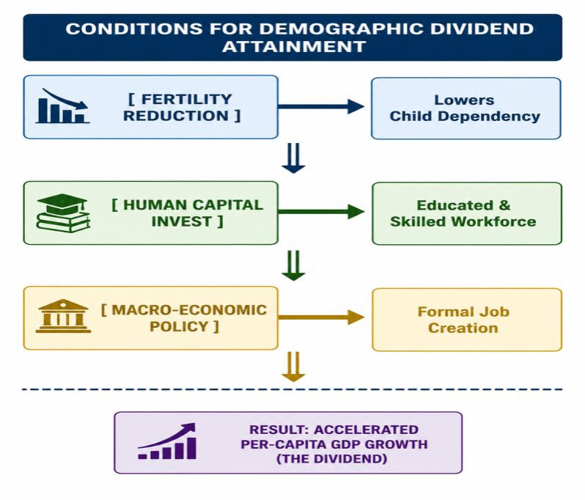
For Ethiopia to capitalize on this window of opportunity the demographic transition must be supported by targeted economic policies:
- Accelerated Fertility Decline:Expanding reproductive health networks to rural zones to further reduce dependency burdens.
- Educational Alignment:Shifting educational curricula away from general humanities toward technical, vocational, and scientific training(TVET systems)to align human capital output with industrial requirements.
- Labor Market Absorption:Scaling up manufacturing sectors,agro-processing and digital economies capable of absorbing millions of new labor market entrants annually. Without formal job creation,the expanding youth cohort can lead to structural underemployment,driving increased irregular international emigration and domestic socio-economic strain.

6. Conclusion
Ethiopia’s current population dynamics present a complex picture of demographic progress balanced by structural vulnerabilities.The transition is evident in rising life expectancies and a steady decline in the macro fertility rate,which point to successful healthcare interventions over the past quarter-century.However the deep regional divide in fertility behaviors, combined with high demographic momentum,ensures that the absolute population will continue to expand.
At the same time internal displacement,climate change,rapid rural to urban economic migration and a reliance on hazardous international migration corridors emphasize the challenges of this transition.Ethiopia’s long-term developmental outlook depends on how effectively it manages this youth bulge.If supported by structural economic reforms,educational investments and institutional capacity building This demographic shift can provide the workforce needed for sustained economic modernization.Conversely if growth outpaces economic opportunities,population pressures will continue to challenge the country's resource distribution and social stability.

References
(2024). Mapping fertility rates at national, sub-national, and local levels in Ethiopia between 2000 and 2019. Frontiers in Public Health, 12. https://doi.org/10.3389/fpubh.2024.1363284 Cited by: 12
Spatial distribution and determinants of children ever born among reproductive age women in Ethiopia: spatial and multilevel analysis of 2019 mini Ethiopian demographic health survey. Frontiers in Reproductive Health, 7. https://doi.org/10.3389/frph.2025.1389932 Cited by: 1
Ayele, D. G. (2015). Determinants of fertility in Ethiopia. African Health Sciences, 15(2), 546–551. https://doi.org/10.4314/ahs.v15i2.29 Cited by: 54
Learning from Ethiopia’s success in reducing maternal and neonatal mortality through a health systems lens. BMJ Global Health, 9(5), e011911. https://doi.org/10.1136/bmjgh-2023-011911 Cited by: 26
Prevalence, spatial distribution and determinants of infant mortality in Ethiopia: Findings from the 2019 Ethiopian Demographic and Health Survey. PLOS ONE, 18(4), e0284781. https://doi.org/10.1371/journal.pone.0284781 Cited by: 7
United Nations High Commissioner for Refugees [UNHCR]. (2025). UNHCR Ethiopia multi-year strategy 2025–2029. UNHCR Operations Plan Report. https://www.unhcr.org/sites/default/files/2025-01/Ethiopia%20-%20Strategy%202025%20%E2%80%93%202029_0.pdf
https://en.wikipedia.org/wiki/Population_pressure

